AP Spanish Language

2017-2018

Sra. Eldridge

meldridge@manasquanboe.org

C:\Users\Maria\AppData\Local\Microsoft\Windows\Temporary Internet Files\Content.IE5\H311OCOV\MC900240623[1].wmf

C:\Users\Maria\AppData\Local\Microsoft\Windows\Temporary Internet Files\Content.IE5\H311OCOV\MC900240623[1].wmf

**Course Overview**: ¡Qué estudiantes valerosos! Es un placer tenerlos en la clase de Español AP este año. Uds. van a desembocar en una misión de usar la lengua española como si fuera la suya. La clase les preparará para tener éxito en el examen pero más importante de comunicar con la gente de otras partes de nuestro mundo. La lengua es un regalo que puede abrir puertas y que puede presentarles a una perspectiva nueva.

**Estrategia para prepararnos para el examen**:

Marking Period 1: Vocabulary Building, Correcting Bad Habits, Expressing Yourself,

Overcoming Inhibitions

Marking Period 2: Advanced Grammar Topics, AP Words, Synonyms, Literature,

Listening Skills

Marking Period 3: Beginning of Test Preparation; “Papas Calientes” and Current

Events

Marking Period 4: Practice, Practice, Practice!!! Finalize Capstone Project.

**Temas:** Success on the AP exam requires you to be a well-rounded academic achiever. This year, we will focus on 6 themes chosen by College Board that will increase your knowledge and vocabulary in both English and Spanish.

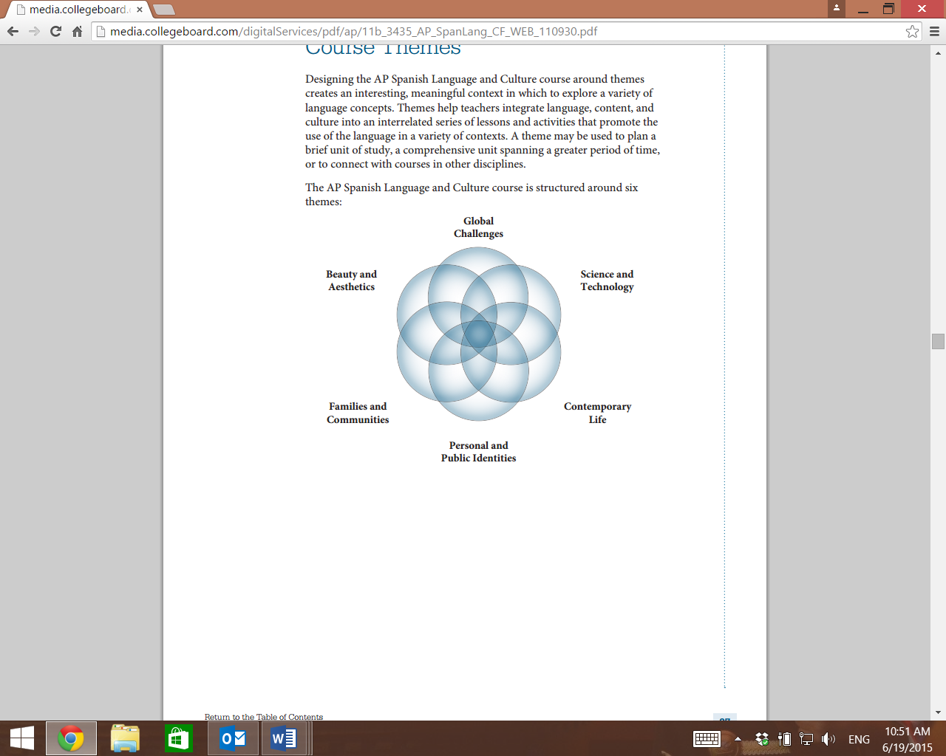

**Course Expectations:** The #1 expectation of you in this course is that you perform at your best on the AP Exam. In order to do this, you must work diligently and thoroughly both INSIDE and OUTSIDE of the classroom.

**Tarea**: Homework will be required of you daily. It is imperative that you take the homework seriously. You will regularly be assigned traditional written homework, but homework will also consist of researching and preparing for the next day’s discussion. You will not be able to participate in the discussion if you have not prepared ahead of time. You must always do your own work and come to class the next day with a product that you are proud of. It is essential that you complete every assignment, therefore if you forget an assignment, you must still complete the assignment and hand it in for a late grade. There will be a deduction of 10% off your grade for every day it is late. Please do not e-mail work unless you have discussed it with me beforehand. As AP students, you are held to the highest standards, and I will not accept anything less than your full effort.

**Canvas:** In addition to the traditional learning environment, you will be expected to complete web-based individual learning. This will be implemented with Canvas. On Canvas, you will submit coursework online adhering to the provided deadlines. Since this course only meets 2 ½ days a week, Canvas will ensure that your learning continues on the days when the course does not meet. Your canvas grade will be averaged as part of your marking period grade.

**Capstone project:** During the first semester, you will be assigned a country of focus. Throughout the year, you will relate the themes that we study to your country through vigorous research and independent learning. At the end of the year, you will present a **bound book** that documents your work throughout the year. Similar to capstone projects in college, it is essential that you work on your capstone project throughout the year rather than cram it in at the end. The capstone project counts as ½ of your final marking period grade.

**Evaluaciones:** Throughout this course, you will be required to complete assessments that will help prepare you for the AP exam. These assessments will cover the areas of Reading, Listening, Writing, and Speaking. The assignments could range from daily discussions and practice activities to timed models from previous AP exams.

**Grading:** Certain assignments will be graded to the AP grading rubrics. It is unrealistic to think that you would score a “5” at the beginning of this course, therefore the grade equations will change as the marking periods change. See the attached rubrics as designated for each marking period.

**Dictionaries and Translators:** In order to truly prepare for the AP exam, it is imperative that you do your homework, compositions, and projects on your own. It is time for you to rely on the vocabulary in your brain and not in a dictionary. It is understandable that you will often be at a loss for a word. Try to work around the word and if you really get stuck, then you can look in a dictionary. You will not have a dictionary for the AP exam. Translators of any kind are not permitted on any assignments and are considered cheating. Other forms of cheating are looking at someone else’s work, plagiarizing, having someone else complete your work for you, using cheat sheets, and many other ingenious ideas that students have come up with over the years. Cheating will result in a zero on the assignment or assessment.

**Final Exam:** There is a final exam, exemption rules do apply.

Rubric Conversions

Marking Periods 1 and 2:

|  |  |  |  |  |
| --- | --- | --- | --- | --- |
| AP | 5 point assignment | AP | 10 point assignment | 20 point assignment |
| 4 | 5 | 4 | 10 | 20 |
| 3 | 4.5 | 3/4 | 9.5 | 19 |
| 2 | 4 | 3 | 9 | 18 |
| 1 | 3.5 | 2/3 | 8.5 | 17 |
|  |  | 2 | 8 | 16 |
|  |  | 1 | 7.5 | 15 |

**late assignments will bump down a grade for each day late

**towards the end of the second marking period, we will start to switch to the next grading scale

Marking Periods 3 and 4:

|  |  |  |  |  |
| --- | --- | --- | --- | --- |
| AP | 5 point assignment | AP | 10 point assignment | 20 point assignment |
| 5 | 5 | 5 | 10 | 20 |
| 4 | 4.5 | 4/5 | 9.5 | 19 |
| 3 | 4 | 4 | 9 | 18 |
| 2 | 3.5 | 3/4 | 8.5 | 17 |
| 1 | 3 | 3 | 8 | 16 |
|  |  | 2/3 | 7.5 | 15 |
|  |  | 2 | 7 | 14 |